**Detailed dataset information sheet**

|  |  |
| --- | --- |
| **Information Objective** | Roads and Transport Hubs |
| **Data Products** | Timber Mills and Major Distribution Centres |
| **Information Source / Model Product** | The Sawmill Database, Google Maps, Earth and Search Engine |
| **Product Completion Progress** | Saw Mills complete  Timber Storage Yards complete  Major Timber Distribution Centres in progress |
| **Dataset / Metadata Document** | Australia - Timber Yards 4th June 2018 GDB  Timber Yards and Mills Metadata.pdf |
| **Dataset Use** | Surveillance Strategy and Design, Pathway risk analysis |

**Background**

A national point feature spatial dataset layer identifying major timber milling operations, timber storage yards and major distribution centres is currently being developed utilising publicly available information from [The Sawmill Database](https://www.sawmilldatabase.com/country_sawmills.php?id=32) (TSD) and Google Earth, Google Maps and associated search engine.

The initial facilities identified from the TSD were further refined by also looking for facilities in close proximity to an Australian Port of Entry. These ports are listed in detail on the [Department of Home Affairs](https://www.homeaffairs.gov.au/trav/ente/avia/maritime/ports-of-entry) website.

**Initial Dataset Procurement Process**

The dataset has been derived by a number of manual processes:

* The list of sawmills for Australia was sourced from the TSD and was manually geo-coded by extracting GPS coordinate values by mapping these sites using Google Earth
* The KML file from Google Earth was imported into ESRI’s ArcMap and converted using the KML to Layer tool
* In the course of locating and visually confirming each site, some of the current ownership details were found to be incorrect or incomplete and these were fixed where possible using information from Google’s search engine
* Creation of a 2 kilometre buffer within ArcMap around the AA ports of entry which is then imported into Google Earth as a layer
* An subsequent search of Google Earth with key words “timber yard” and “saw mill” was conducted (Figure 1)
* Visual scan of the environment within and surrounding these buffers and the facilities captured from the search results to identify and capture timber mills and storage yards (Figures 2-3)
* Export of the final Google Earth KML layer to file
* Conversion of this layer within ArcMap using the KML to Layer (Conversion) tool to create and editable shapefile layer

Figure 1. Google Earth view of “timber yard” search results and AA port of entry 2km buffer (orange circle)

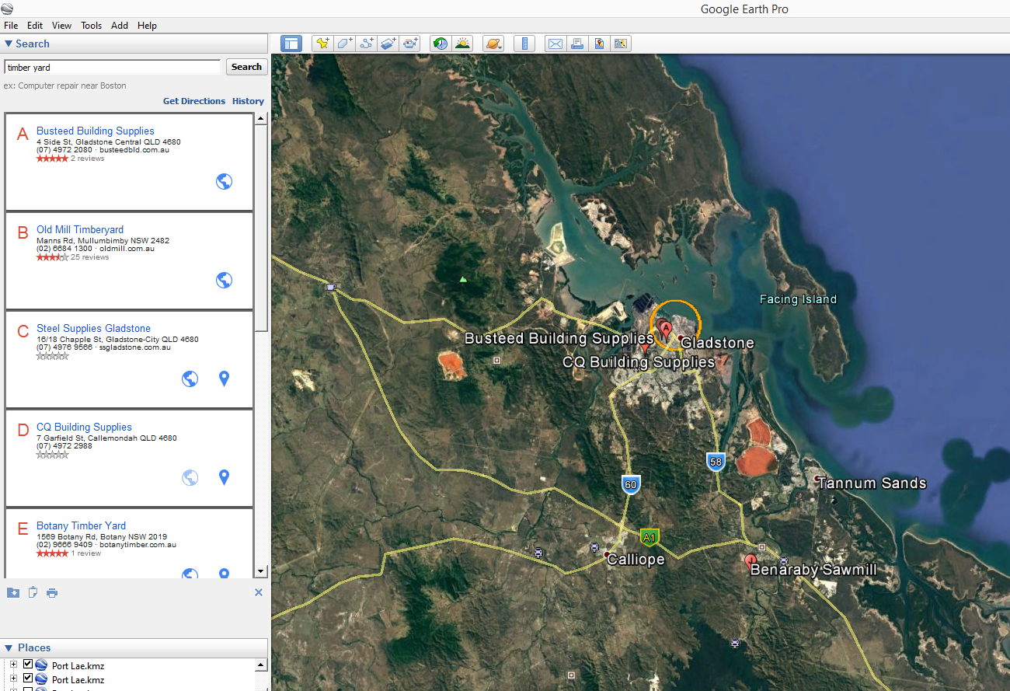

Figure 2. Google Earth view of captured facility locations” and AA port of entry 2km buffer (orange circle)

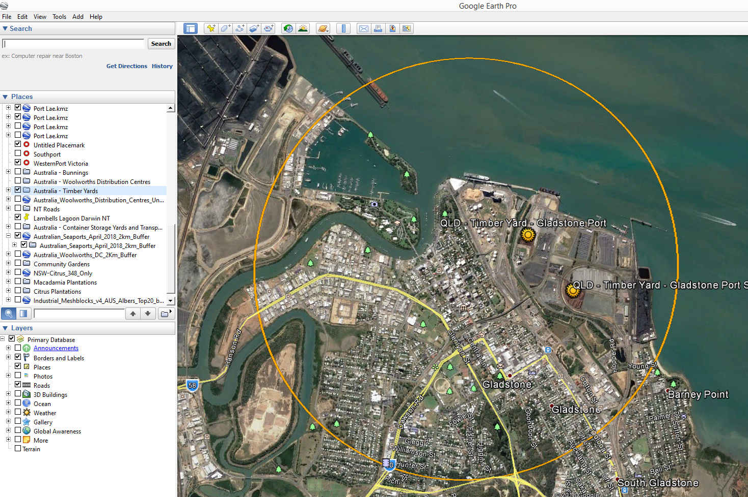

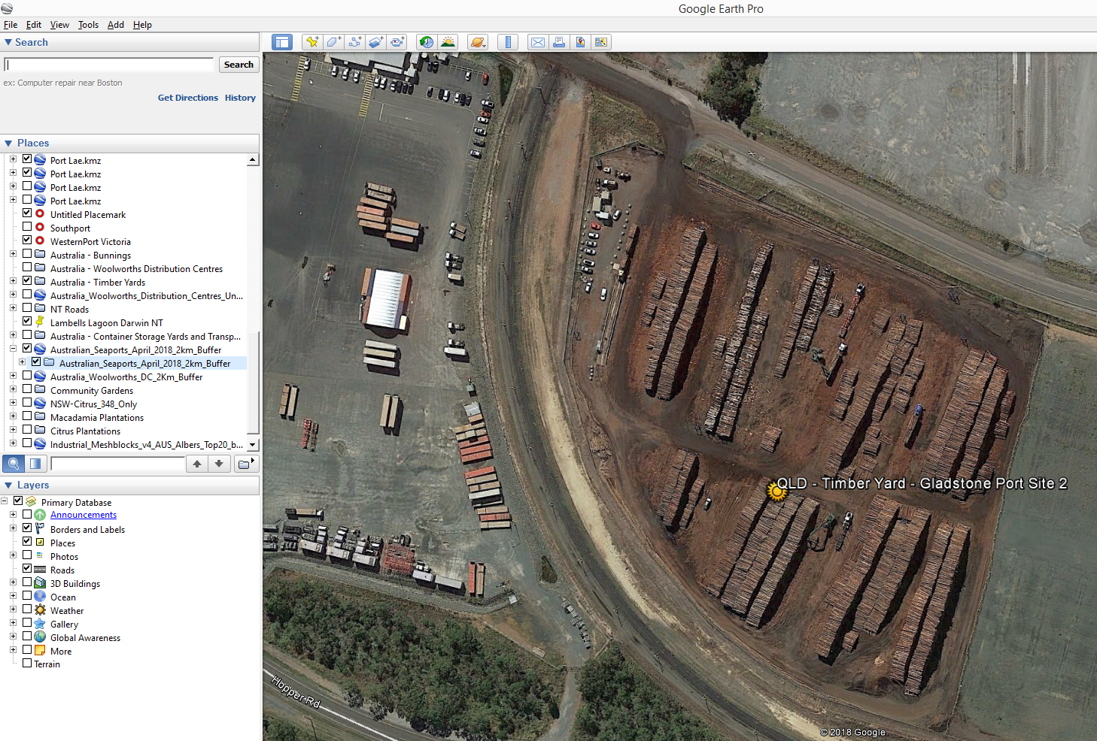Figure 3. Google Earth close-up view of captured facility locations” and AA port of entry 2km buffer (orange circle)

**In progress Dataset Procurement Processes**

Following this initial data compilation, it is likely that the location of major timber distribution centres would also be a valuable asset to have.

Therefore a similar approach can be adopted as per the points outlined in the initial data procurement section.

The only difference would be to search Google Earth with key words “timber distribution” and possibly “timber supplies”.

**Limitations**

* None considered at this stage of the procurement

**Quality Check**

By reverse checking for facilities within and surrounding AA port of entry that may have been missed in the initial visual scan, an extra 15 facilities have been captured to date.

Table 1. Summary of the datasets and their completion status to date

|  |  |  |  |  |
| --- | --- | --- | --- | --- |
|  | **Initial feature Count** | **Additional features detected using AA ports of entry 2km boundaries** | **Estimated number of major timber distribution centre features to be captured** | **Estimated total feature count of completed dataset** |
| **Australia** | **29** | **15** | **~150** | **~200** |

Discussion and Future Work

Future work may include quality assurance checks to confirm ownership details and ensure facilities identified are still operating.

Expansion of the visual scanning zone to all built areas and/or smaller ABS Industrial meshblocks in the industrial areas around each AA port and within major capital city urban sprawl extents.

Calculation of useful feature attributes such as:

* Quantity of timber in cubic metres of storage yard facility
* Proximity in kilometres to major freight hubs, AA ports of entry and community gardens

Project Resources Estimates and Uses

An estimate of the timeframes and data procurement requirements required to complete this dataset is summarised in Table 2.

The end result will be a dataset product which is of a High to Authoritative quality and can be referenced as a point of truth data source for input into projects such as surveillance strategy and design.

This dataset will provide accurate and useful information such as:

* Timber Mills, storage yards and major distribution centres
* Ownership and Contact information
* Area sizes
* Timber volumes per storage site

And will assist in:

* Serving as an input in estimating labour and capital resources for conducting surveys for pests such as those in the National Priority Plant Pests (NPPP) target groups, e.g. number of field officers required to inspect a given quantity of logs or timber over a specified amount of time
* Mapping requirements for national/state emergency response programs that are deployed when these pest incursions occur
* Providing a feed-in data layer alongside the national road network for determining distribution pathways and the risk levels of these pathways

Table 2. Comparison of process methods and output dataset quality expectations

|  |  |  |  |  |
| --- | --- | --- | --- | --- |
| **Process** | **Requires Industry Assistance** | **Requires State Government Assistance** | **Estimated time to complete** | **Expected Dataset Quality Level** |
| 1 | Possibly – for quality checking operational status and ownership details of identified facilities | No | ~ 2 weeks | High to Authoritative |